Part 1 — Create Security Group
Go to:
EC2 → Security Groups
Click Create Security Group
Configuration
Setting | Value
Security Group Name | studentname-sg
Description | Security group for web server lab
VPC | Default
Add Inbound Rules
Type | Port | Source
SSH | 22 | My IP
HTTP | 80 | Anywhere
Result:
Rule | Purpose
22 | SSH access
80 | Web server access

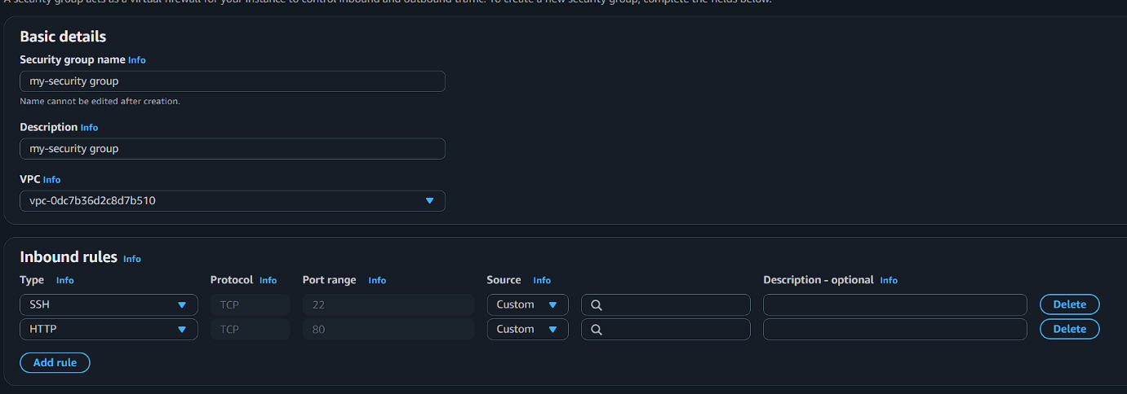
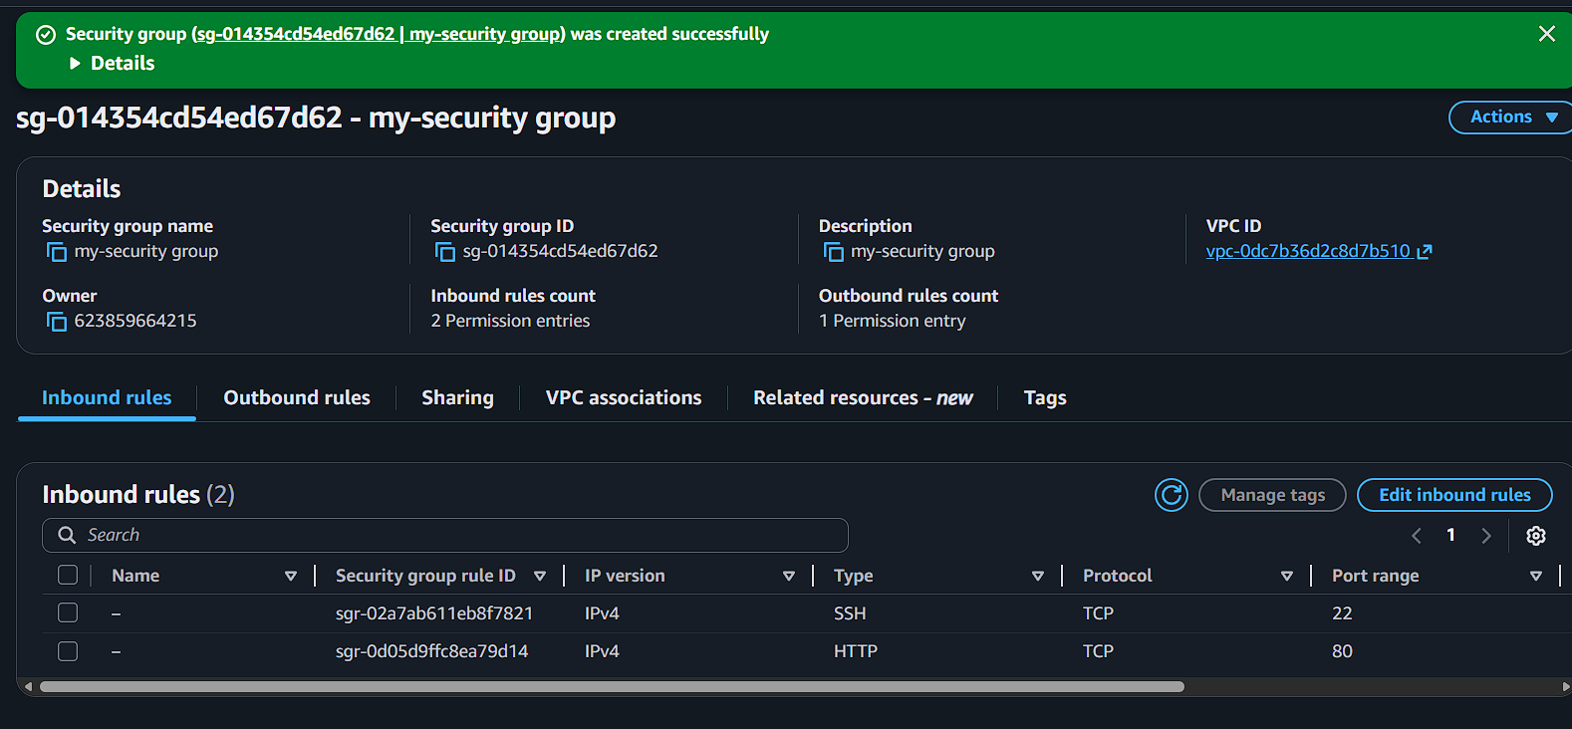

Click Create Security Group

Part 2 — Create EC2 Instance
Go to EC2 → Instances → Launch Instance
Configure Instance
Setting | Value
Name | studentname-ec2
AMI | Amazon Linux 2
Instance Type | t2.micro
Key Pair | existing or create
Security Group | Select existing → studentname-sg
Launch instance.
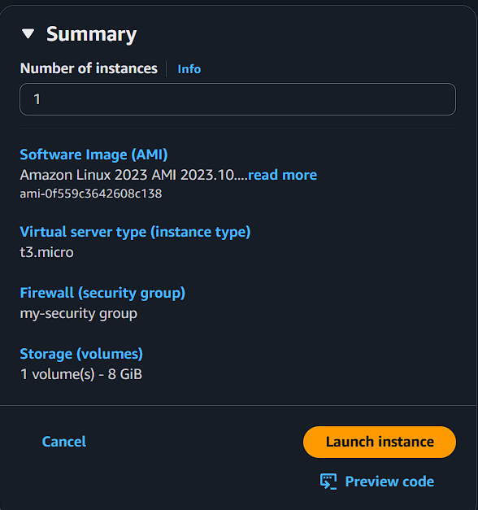

Part 3 — Connect to EC2 via SSH
After instance is running.
ssh -i key.pem ec2-user@public-ip
Verify connection.
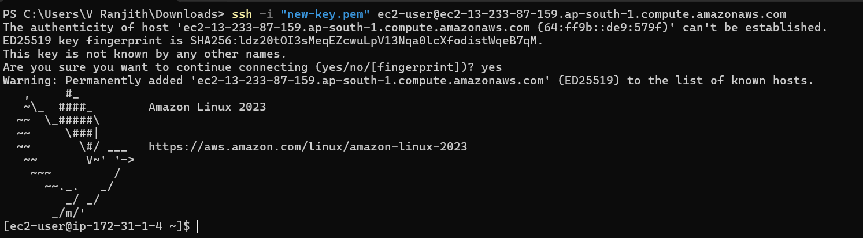

Part 4 — Install Web Server
Inside EC2 install Apache HTTP Server
sudo yum install httpd -y
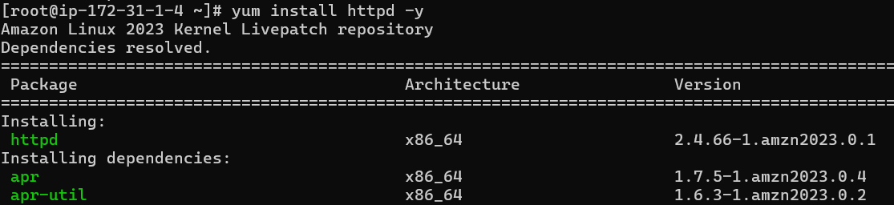
Start service
sudo systemctl start httpd
sudo systemctl enable httpd
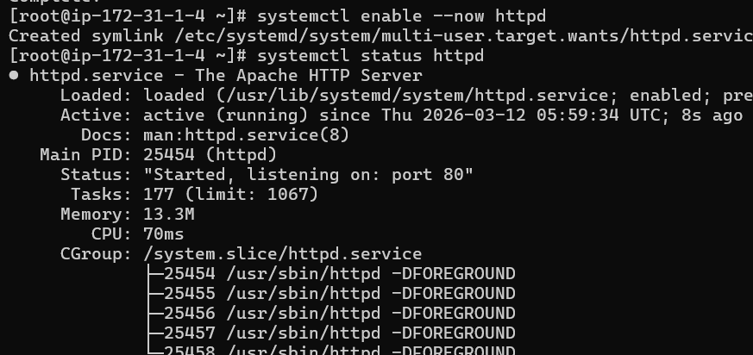

Part 5 — Create Web Page
sudo echo "Welcome to AWS Security Group Lab" > /var/www/html/index.html
Verify
curl localhost
Expected output
Welcome to AWS Security Group Lab

Part 6 — Test HTTP Access
Open browser
http://EC2-PUBLIC-IP
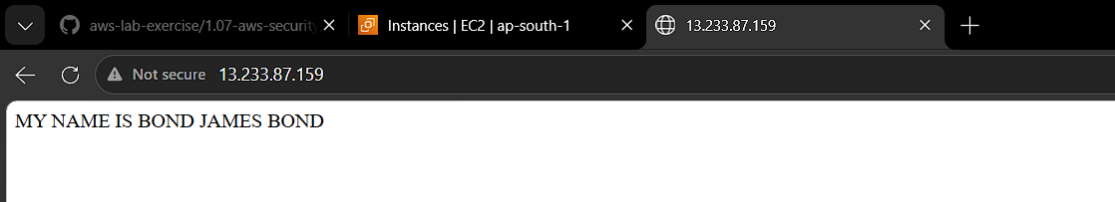

Expected:
Welcome to AWS Security Group Lab
This works because port 80 is allowed in the security group.

Part 7 — Validate SSH Access
From your laptop:
ssh -i key.pem ec2-user@public-ip
SSH works because port 22 is allowed.


Part 8 — Remove Security Group Rules
Go to:
EC2 → Security Groups → studentname-sg
Edit Inbound Rules
Delete:
Port
22
80
Save rules.
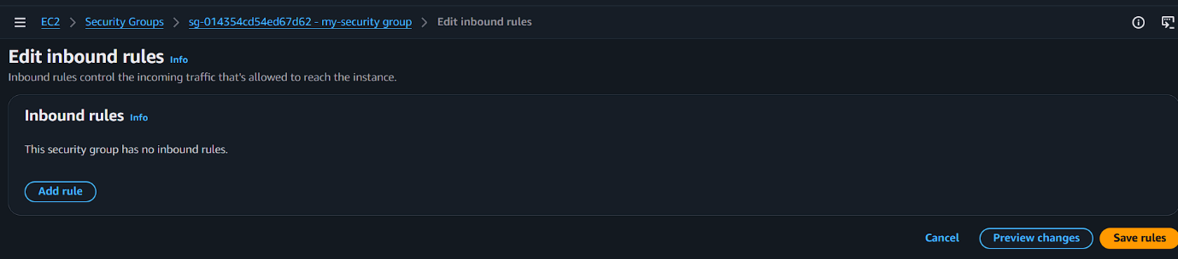
Now no inbound access allowed.

Part 9 — Validate Access After Removing Rules
Test SSH
ssh -i key.pem ec2-user@public-ip
Result:
Connection timed out
SSH blocked.
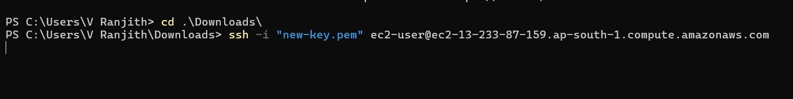

Test HTTP
Browser:
http://EC2-PUBLIC-IP
Result:
Site can't be reached
HTTP blocked.
